**GROOVY ASSIGNMENT**

a. What data type is the number 2? How about 20? 200? Keep adding

zeros and watch the data type change until it reaches Big Integer. Then

do the same for 2.0.

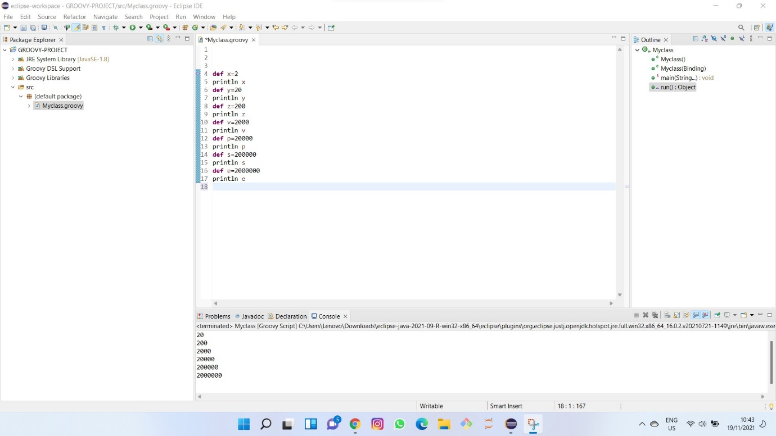

b. Declare a variable x of type def and assign it the sum of 1 and 1.5.

What is the resulting data type?

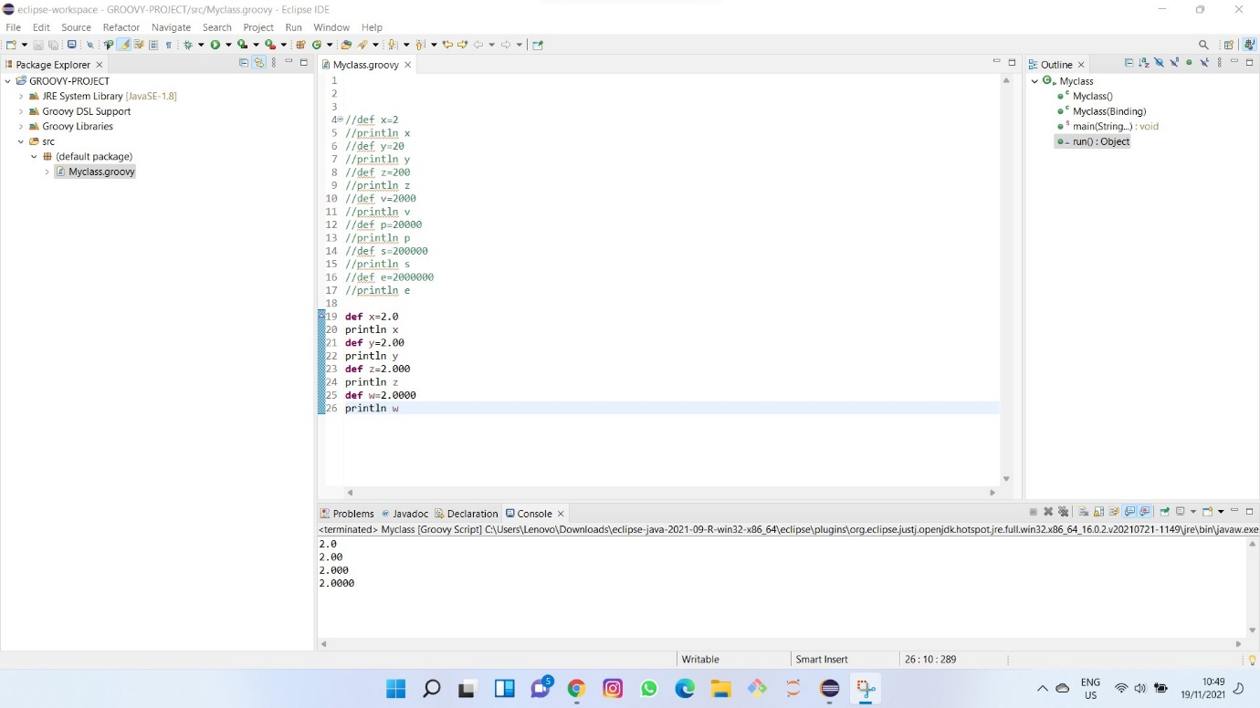

c. What do you get when you divide 5 by 2? What is the resulting data

type? If you wanted to do integer division (no remainder), what method

would you call?

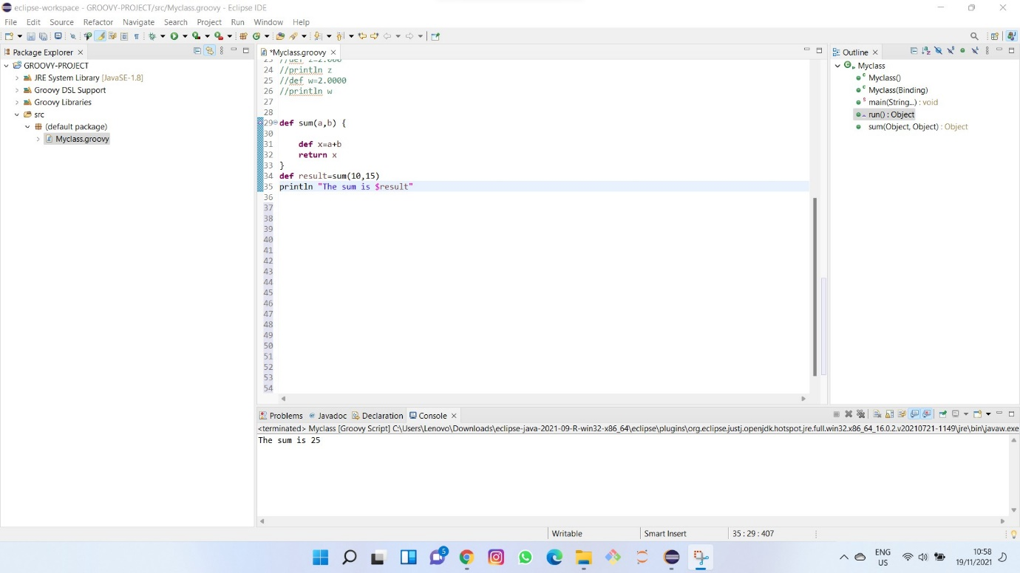

What do you get when you divide 5 by 2? What is the resulting data

type? If you wanted to do integer division (no remainder), what method

would you call?

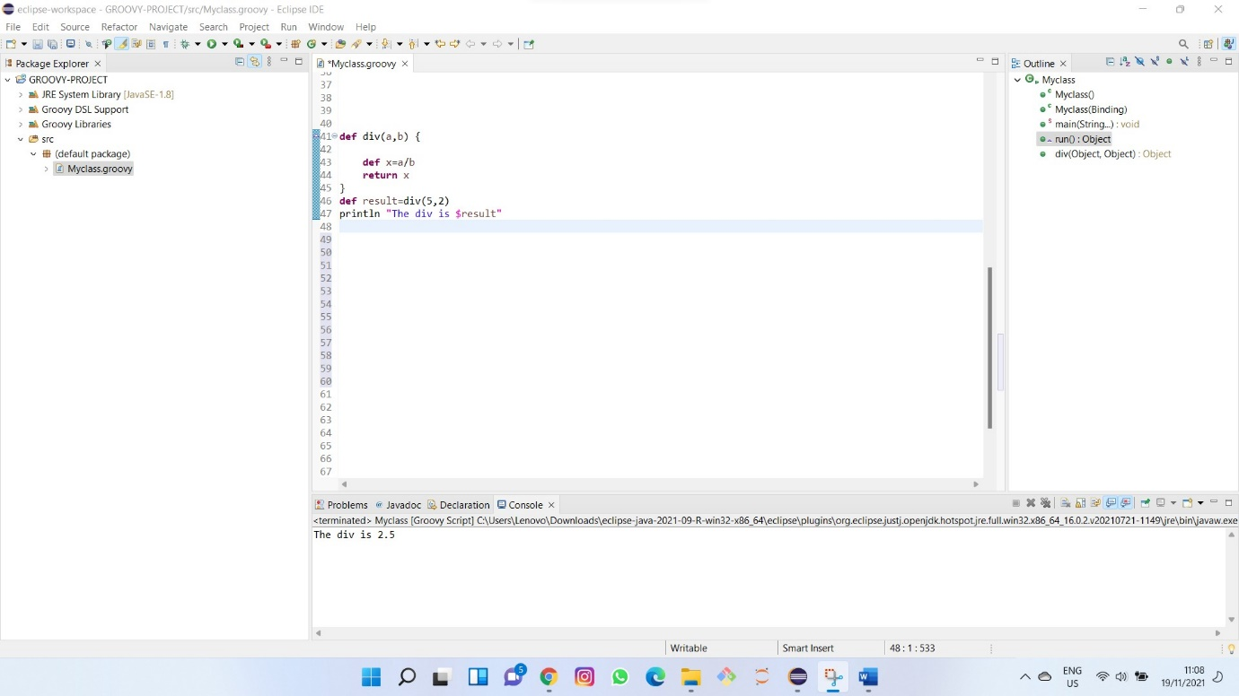

2. Wrapper Classes

From the associated wrapper classes, find the min and max values for

the primitives: byte, short, int, long, float, double.

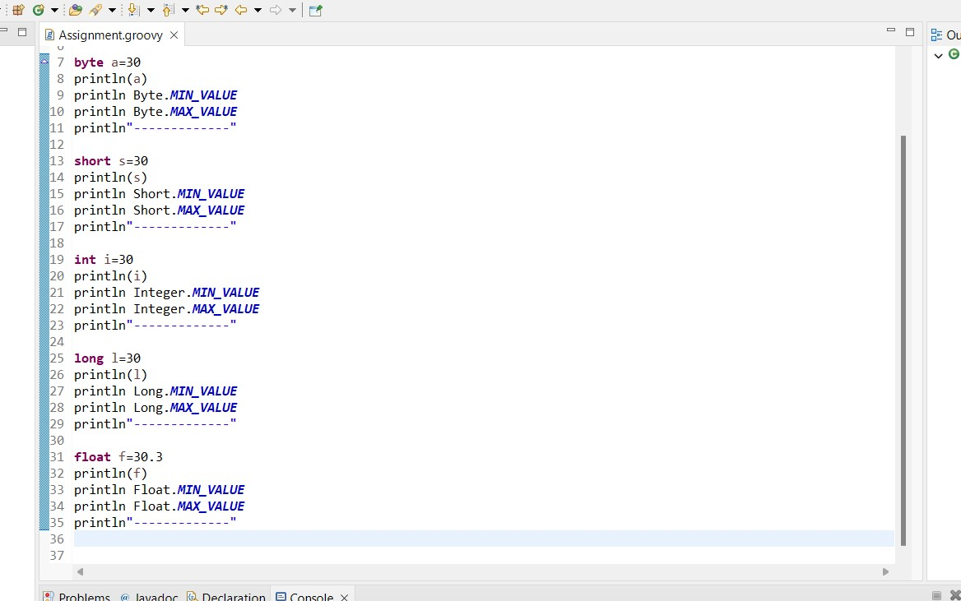

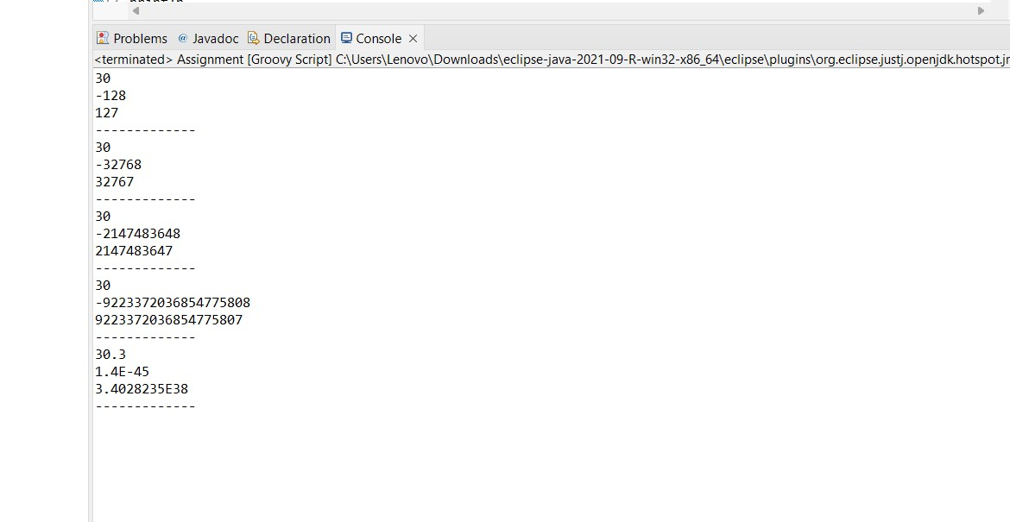

4. Strings and Groovy Strings

a. How many characters are in the string & Hello, Groovy!?

b. Define a string variable containing a name. Print a hello statement

with your name using string concatenation, then using a Groovy string.

c. Demonstrate that racecar is a palindrome by comparing it to its

reverse. Do the same with Bob, removing case sensitivity first.

d. Define a string variable containing the sentence, Hello, World. How

are you? Split the sentence into an array using the split method. Count

the number of words. Do the same using the tokenize method.

e. Using the same sentence, use array notation (square brackets) to print

the substring World.

f. Use array notation to print the last word, but reversed.

5. Prime Numbers

Write a method called is Prime that takes an integer argument and

returns a boolean. Determine whether the number is prime by dividing it

by all numbers from 2 up to one less than the number.

That limit is too high, of course. How high do you have to check to be

sure whether you&#39;ve gone far enough?

1. Sorting Strings

Create a list of strings. Sort them alphabetically. Sort them by length.

Sort them by length in descending order.

Advanced: Sort by length, then sort equal length strings alphabetically

2. Processing a list of numbers

Create a list of numbers. Add them together. First double each number,

then add them up. Compute their average.

3. Reading a web page

Using the Groovy JDK, access your home page and display the source

code. Print the length of each line of the home page.

4. Closures as a filter

Create a list of numbers. Print all elements greater than zero.

5. Multi-line strings

Make a multi-line string. Compute the number of vowels on each line.

6. Padded binary output

Print the numbers from 0 to 15 in binary (use

Java&#39;s Integer.toBinaryString() method). Use a method in String from the

Groovy JDK to make all the output values have four digits.

1. Encode and decode

i. Create two strings, one for a username and one for a password.

Concatenate them together, separated by a colon. Use a method

from the Groovy JDK to convert the resulting String to a byte

array. Then use the encodeBase64 method on byte array to create

an encoded string.

ii. Decode the string by using the decodeBase64 method, and using

the result as an argument to the String constructor. Use the split

method to return the original username and password.

2. Sorting a list

Create a class called Course, with a String attribute called name and

an int attribute called days. Create a list of four course instances, where

at least two have the same number of days. Sort the list by number of

days. Then, sort the list by days, but when the days are equal, sort by

name.

3. Operator overloading

i. Create a class called Money with a double amount and

a String currency (like USD or EUR). Implement a plus method that

checks that the currencies are the same and, if so, returns a

new Money instance with the sum of the amounts and the correct

currency. Write a similar minus method.

ii. Write a MoneyTest class in Groovy that uses + and - and verifies

that they work properly.